Burn Severity Mapping using dNBR and BARC

What the tool does: This tool will take a fire perimeter and use pre and post fire Landsat images to detect burn severity of vegetation. The images are compared and a severity polygon layer is created based on the fire perimeter.

Generally Post fire Landsat images are Landsat 7 or Landsat 8 with 8 being the most prefered. Pre fire Landsat images being 5, 7 or 8 with the most preferred being Landsat 8.

Required:

1. USGS Landsat account to browse and download Landsat Data
2. Fire perimeter shapefile
3. Post fire Landsat Image placed in separate folder
4. Pre fire Landsat Image placed in separate folder

Landsat Images can be browsed and obtained at:

* http://earthexplorer.usgs.gov/
* <http://glovis.usgs.gov/>

Tips for selecting imagery to create a successful BARC:

1. Select acquisitions that are cloud and smoke free over the target event
2. Try to use imagery from August to mid September with the aim that non-burnt vegetation be of similar green up levels in the pre and post event imagery. For best results it is desirable to have imagery from a period of peak photosynthetic activity.
3. Try and use image pairs with the as little time separation as possible. This will minimize the amount of non-event related change effecting the BARC .Landcover changing events such as harvesting, senescence, mountain pine beetle, and blow-downs will affect the BARC.
4. The Landsat 7 sensor data can be used but it has blank scan lines in the image which affects completeness of the image and analysis.

The BARC toolbox (Figure 1) contains two tools written specifically for BARC map creation. These scripts are written using Python 2.4.4 for use with ArcGIS 9.3 licensed for ArcInfo with the Spatial Analyst extension. The tool will work in ArcInfo version 10.1



Figure 1: The Burn Area Reflectance Classification toolbox

The BARC tools take USGS imagery, the fire perimeter file, and user defined differenced normalized burn reflectance break values to create a shape file containing areas of high, medium, low, and unburned burn severity classes.

Creating BARC polygons with the BARC toolbox

Step 1: Download the pre and post fire imagery and extract to separate folders. Use 7 zip to extract all Lansat files

Step 2: Create the differenced normalized burn ratio raster using the tool provided (Figure 2).

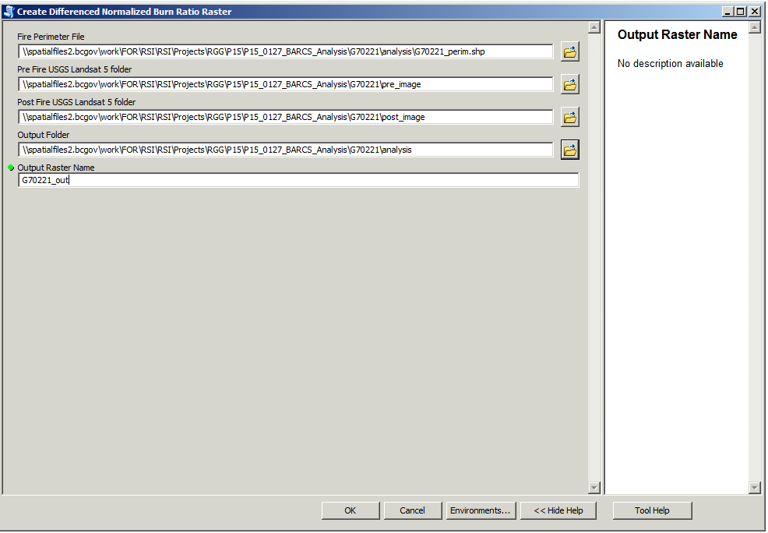

Figure 2: The Create Differenced Normalized Burn Ratio Raster tool.

Step3: Create the BARC polygons using the previously created data.

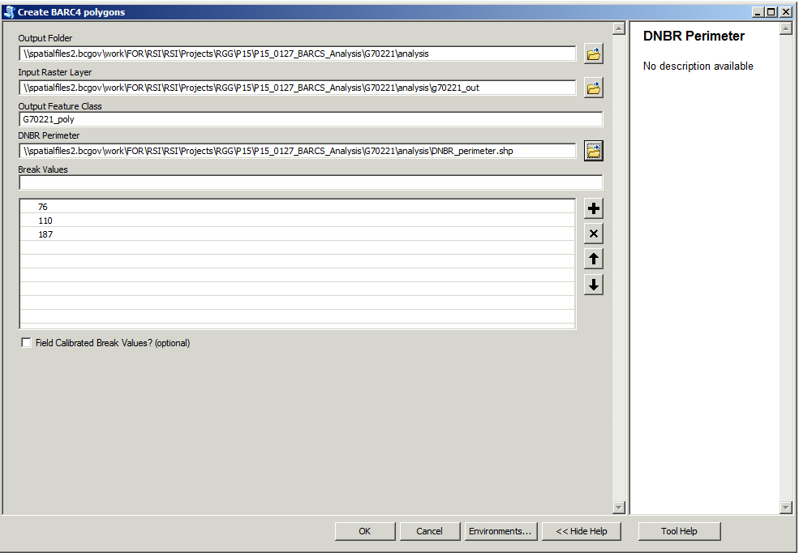

Figure 3: The Create BARC4 Polygon tool. The above break values are provided as a default for initial classification purposes. These breakpoints are to be refined using data collected in the field. In the case of the default breakpoints burn severity classes will be assigned as Unburned (<=76), Low (77<=110), Moderate (11<=187), High (>187). Field validation may change these break points plus/minus ten.

USFS backgrounder link – <http://www.fs.fed.us/eng/rsac/baer/barc.html>